**Bootstrapping**

**Contents**

Scope 2

Problem Statement 2

Introduction 2

User data 2

Example Script 2

Implementation 3

1. Bootstrapping for Linux 4

Example 1 5

Example 2 7

2. Bootstrapping for Windows 9

Example 1 9

Example 2 10

3. Bootstrapping for Ubuntu 12

Example 12

Benefits 14

Limitations 14

**Bootstrapping**

Document Name: Bootstrapping

Owner :Hema Paul

**Scope**

When you launch an Amazon EC2 instance, you have the option of passing user data to the instance. The data can be used to perform common automated configuration tasks and even run scripts when the instance boots.

**Problem Statement**

Bootstrapping in AWS means to add commands or scripts to AWS EC2's instance User Data section that can be executed when the instance starts. It is a good automation practice to adopt to ease configuration tasks.

**Introduction**

**User Data**

A script that runs on first launch of an Amazon EC2 instance. Used for configuring the server during launch.

**Example Script :**

#!/bin/bash

yum update -y

amazon-linux-extras install -y lamp-mariadb10.2-php7.2 php7.2

yum install -y httpd mariadb-server

systemctl start httpd

systemctl enable httpd

usermod -a -G apache ec2-user

chown -R ec2-user:apache /var/www

chmod 2775 /var/www

find /var/www -type d -exec chmod 2775 {} \;

find /var/www -type f -exec chmod 0664 {} \;

echo "<?php phpinfo(); ?>" > /var/www/html/phpinfo.php

**Implementation**

**Steps for bootstrapping for Linux**:

1. Log on to EC2 Instances
2. Click on Launch Instances
3. Provide appropriate name for the instance

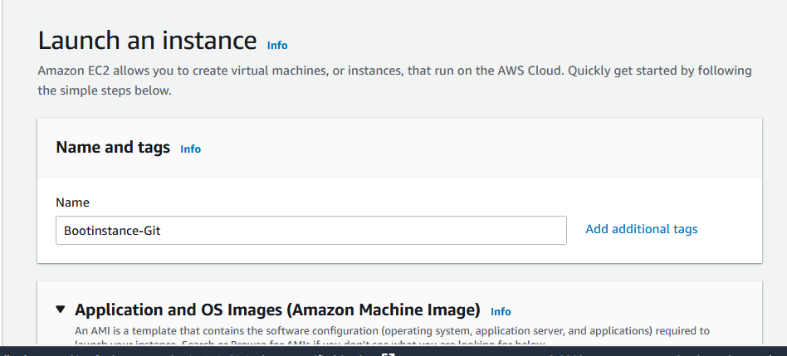

1. Choose the AMI.

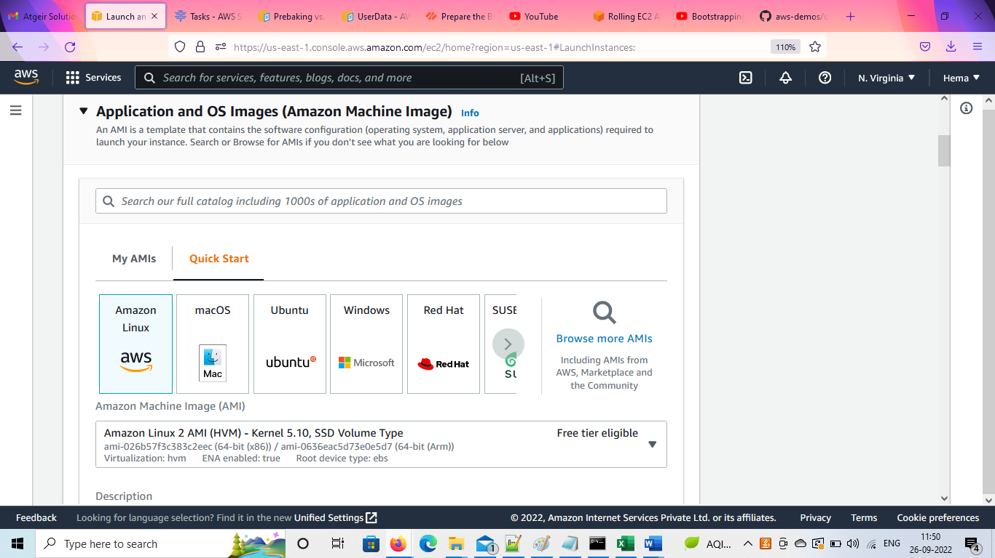

1. Choose/Create Keypair

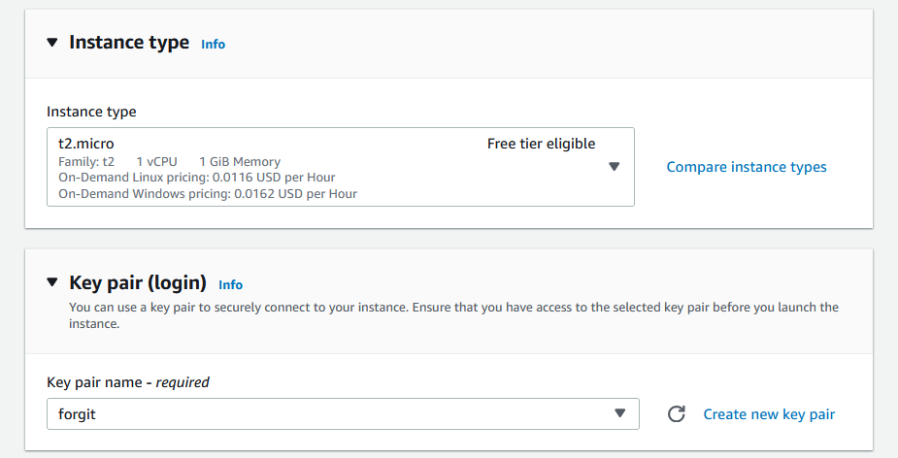

1. Create security group / Select existing security group

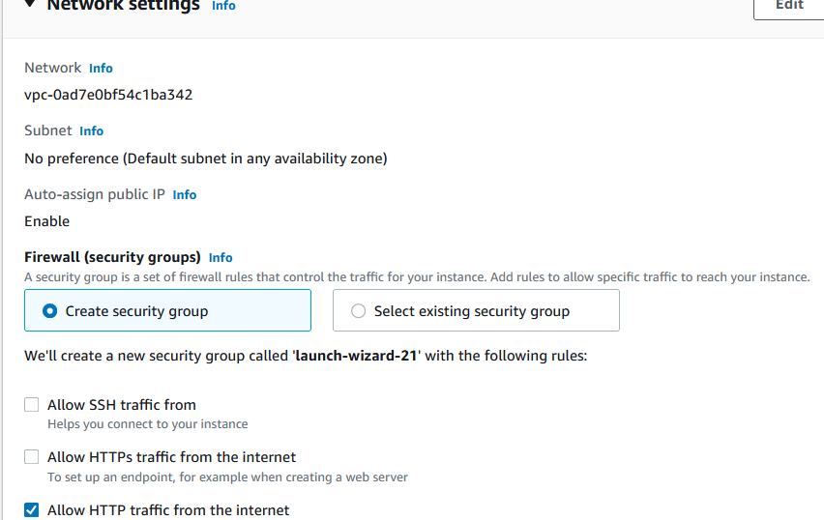

1. Select user data field in Advanced details

**Example 1**

Provide user data script in the field

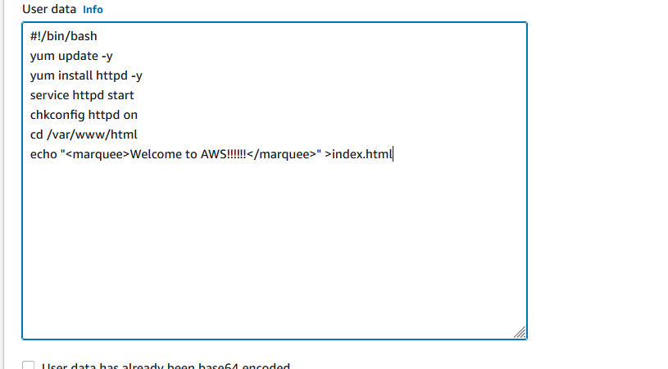

1. Click on Launch instance

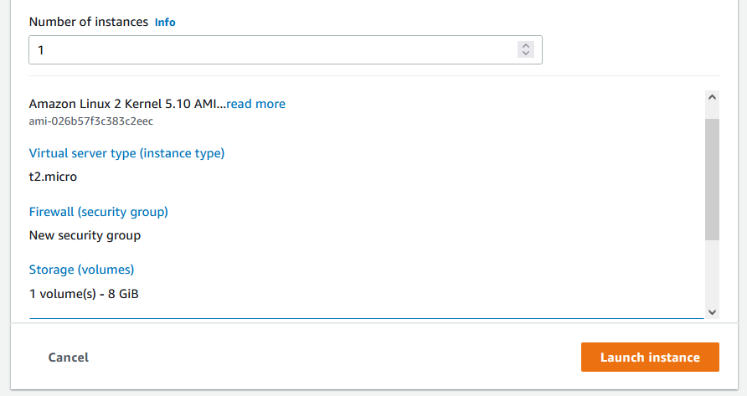

1. Upon launching the instance the script provided in the user data section will get executed and get attached with the instance.

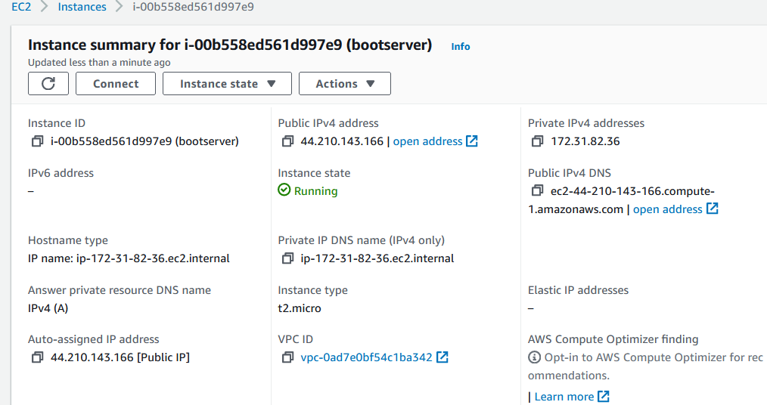

1. Paste the **Public Ip address** on browser window to see the script got executed



**Example 2:**

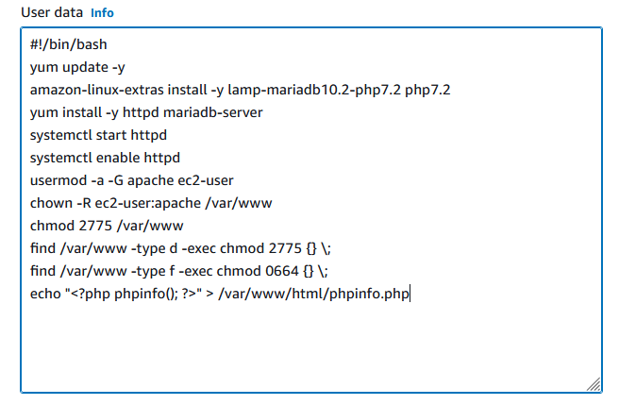

Check whether Apache installed by copying the public ip on browser window

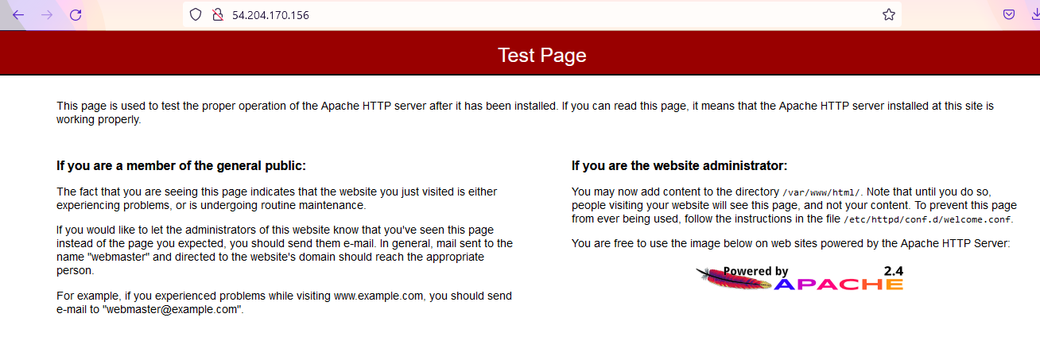

Now check the info for PHP

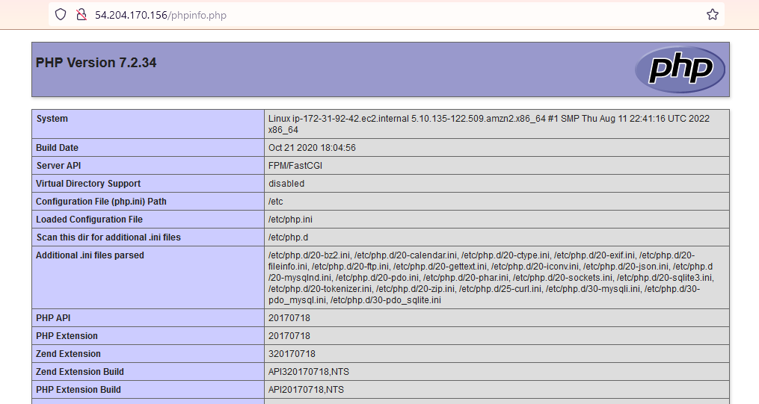

We can doublecheck by connecting the instance to SSH

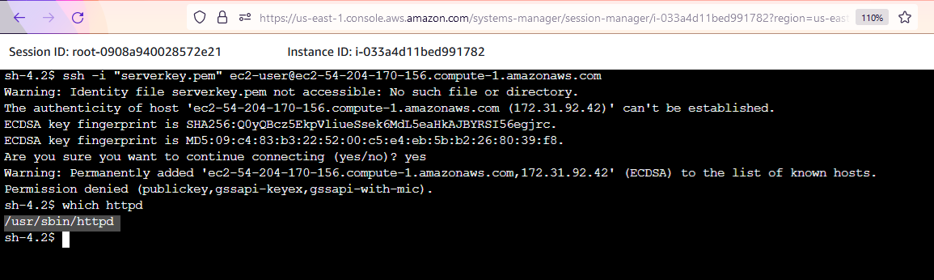

**Steps for bootstrapping for Windows :**

1. Repeat the previous steps for linux
2. Insert the script in userdata in User data field of Additional details

**Example 1**

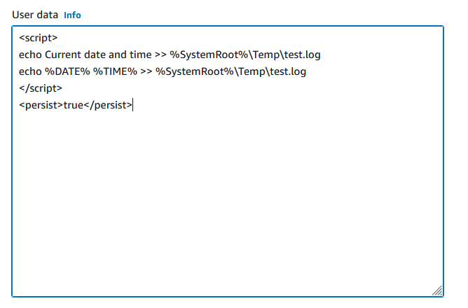

1. Connect the instance with RDP Client.
2. The result of the running instance is seen in the remote desktop

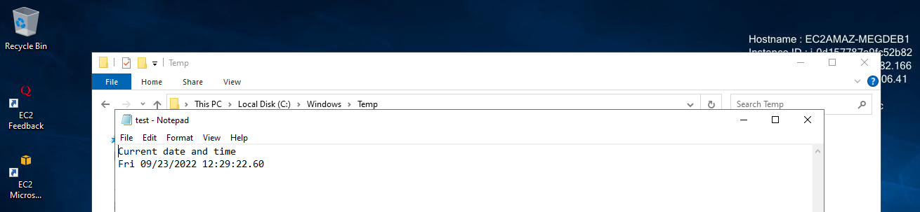

Example 2

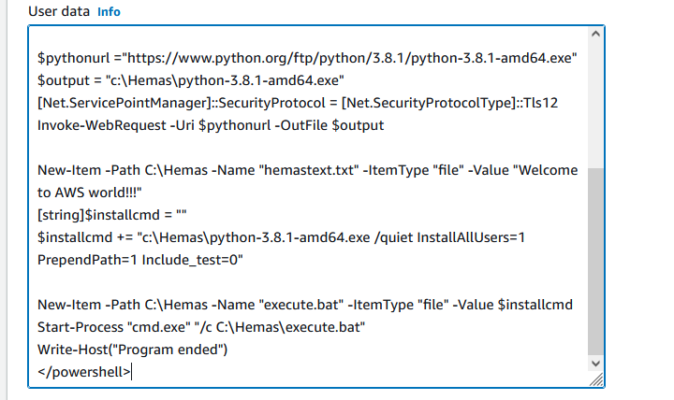

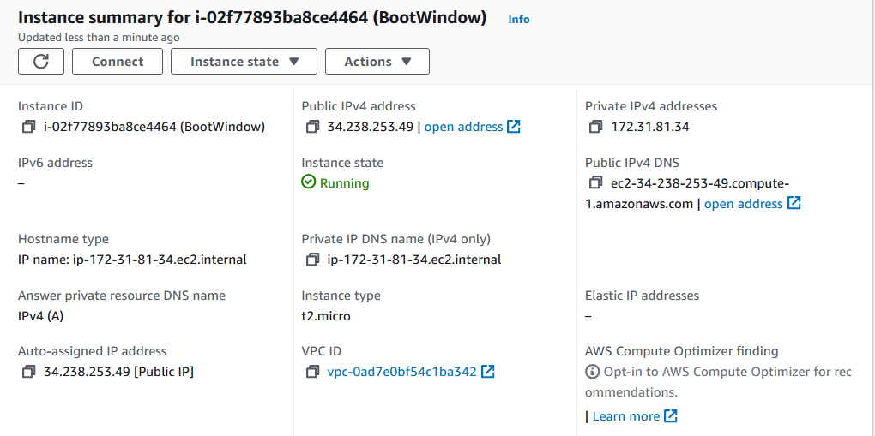

The following window shows the script got executed.

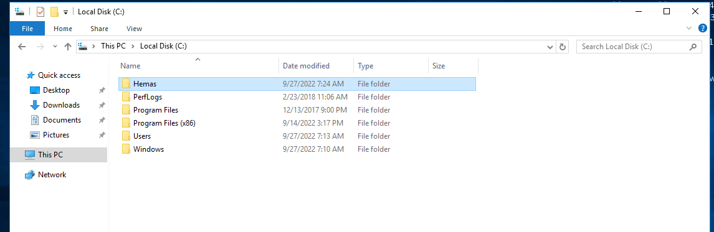

The modules installed is shown inside the folder in remote desktop.

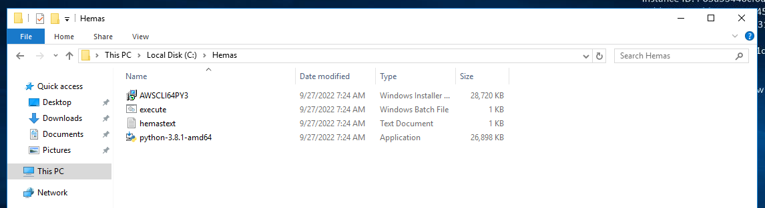

Opening the text folder created , it shows the content given through the script

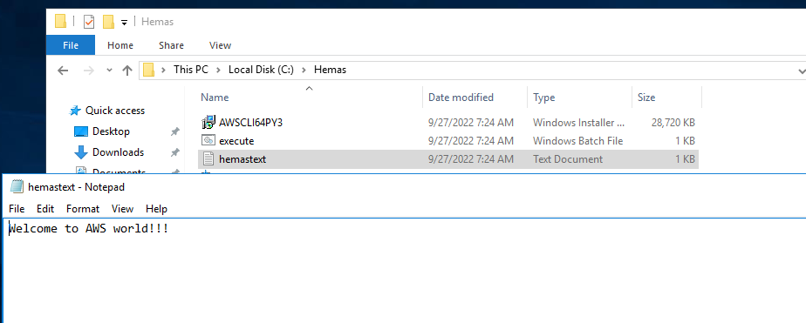

Check whether the python module is installed in command prompt

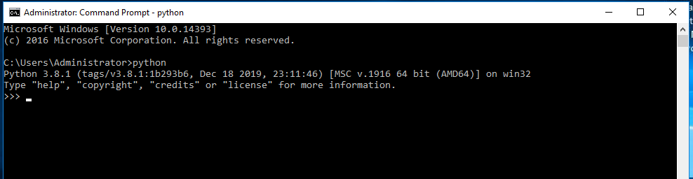

Check whether AWSCLI is installed in command prompt

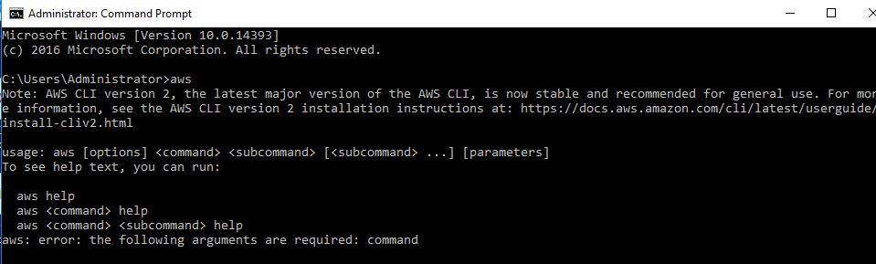

**Steps for bootstrapping for Ubuntu :**

1. Repeat the previous steps for linux and windows for creating instance
2. Insert the script in user data in User data field of Additional details

**Example**

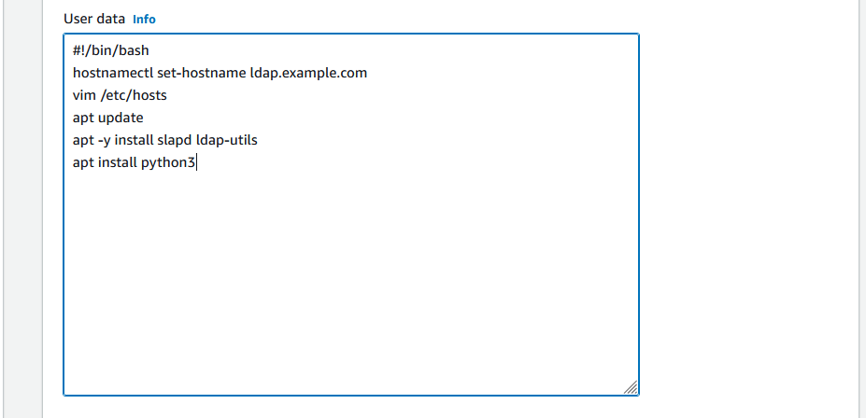

View instance summary

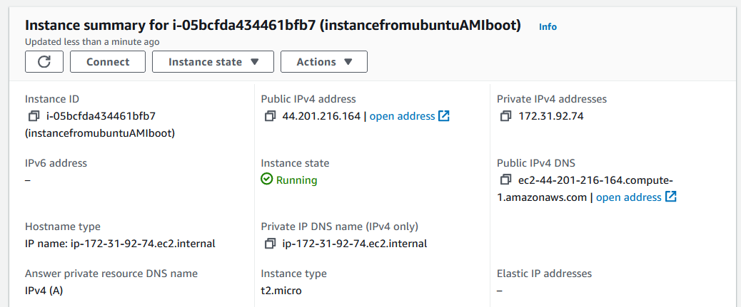

Connect and check for the installed modules:

OpenLDAP

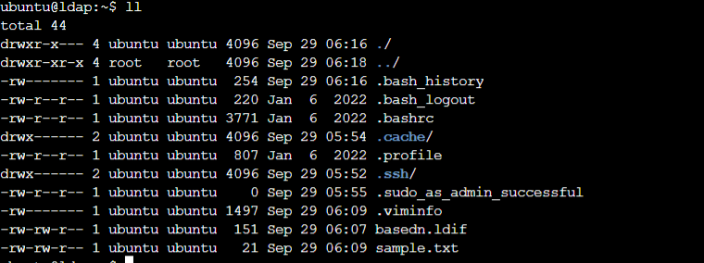

Python3

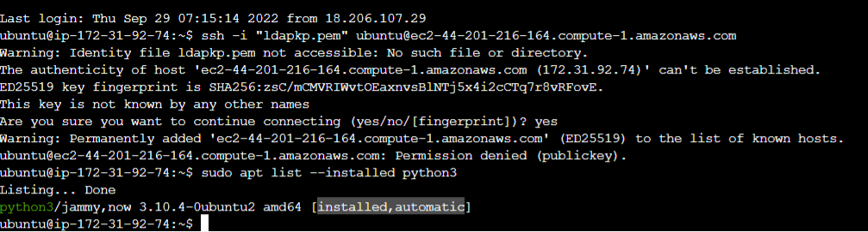

**Note**: When you update instance user data, **user data scripts are not run automatically when you reboot or start the instance**. However, you can enable user data execution so that user data scripts are run one time when you reboot or start the instance, or every time you reboot or start the instance by setting the persist command true. (<persist>true</persist>)

**Benefits**

* We can recreate the different environments for Dev, QA, and Production etc. with minimal effort by using bootstrapping.
* Bootstrapping instances gives more control over cloud-based resources in AWS.
* It also minimizes the occurrence of human related deployment errors.
* One main benefit for Bootstrapping is that it can create a Self-Healing and Self-discoverable environment. Such a system is more resilient to hardware failure in Production.

**Limitations**

By default, user data scripts run only the first time when the EC2 instance is launched during the first boot cycle.